|  |  |
| --- | --- |
| **STREAMANALYTIX 3.1.0** | Learn about-**ElasticSearch -Channel** |

# Custom ElasticSearch Channel

ElasticsSearch is a search engine based on Lucene. It provides a distributed, multi tenant-capable full-text search engine with an HTTP web interface and schema-free JSON documents. Elasticsearch is developed in Java and is released as open source under the terms of the Apache License.

## Configure ElasticSearch Channel For Batch

**Step 1:** Drag the ElasticSearch Chanel on the pipeline canvas and right click on it to configure. On the Select Message tab, select a Message Type and provide a Message Name

|  |  |
| --- | --- |
| **Field** | **Description** |
| **Message Type** | **Single:** If only one message needs to be parsed in the pipeline.  **Multi:** If multiple messages needs to be parsed in the pipeline. |
| **Message Name** | Click on the Message Name input field to get a list of all the messages and select message(s). |
| **Schema Identifier** | In case, you have written your own code for schema identification, check the box to provide fully qualified name of your class. |

**Step 2:** Configure ElasticSearch channel properties on the **Configuration** tab.

Shown below is the default configuration of ElasticSearch Channel.

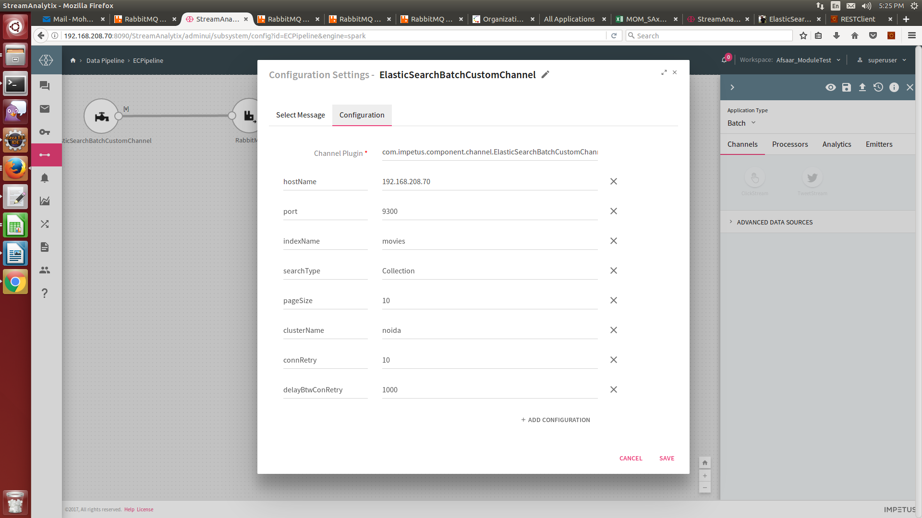

|  |  |
| --- | --- |
| **Field** | **Description** |
| **Channel Plugin** | Fully qualified name of the channel class. com.impetus.component.channel.ElasticSearchBatchCustomChannel |
| **hostName** | Host Name where ElasticSearch cluster is hosted |
| **port** | Transport protocol Port number of Elastic Search |
| **IndexName** | Elastic Search index from where data is to be fetched |
| **type** | Index type (used for internal mapping) |
| **searchType** | Search on the basis of query or collection or custom. Values accepted by this field are **Query** and **Collectio**n and **Custom** |
| **query** | Elastic Search Query in json format/ query String (configure only if searchType is query) |
| **pageSize** | Number of records to be fetched in a single hit. |
| **ClusterName** | Name of ElasticSearch Cluster |
| **connRetry** | Number of times ElasticSearch channel will try to connect with Elastic Search server. |
| **delayBtwConRetry** | Mili seconds delay when ElasticSearch channel tries to connect with ElasticSearch server. |
|  |  |

**Some additional features of ElasticSearch Custom Channel:**

1. **Range Filter**

When **searchType** is **Collection,** filtration of query data can be performed on the basis of date by using Range Filter.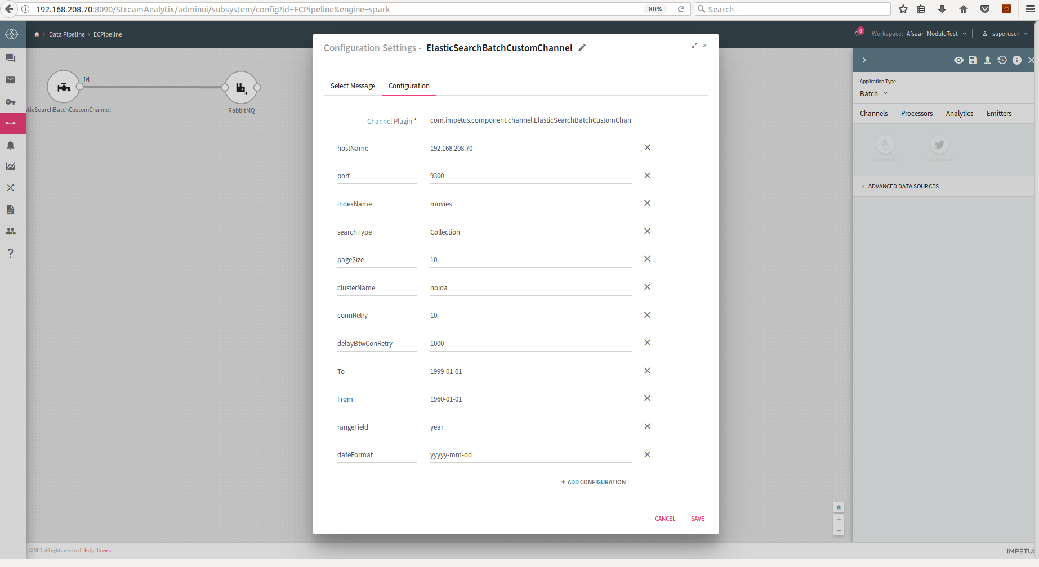

**Range Filter Parameters:**

|  |  |
| --- | --- |
| **Field** | **Description** |
| **To** | Start of range value(INT or DATE) |
| **From** | End of range value(INT or DATE) |
| **rangeField** | Field onto which filtration can be done |
| **dateFormat** | Date format if filtration is done on date value |

1. When **searchType** is **Collection,** custom channel can fetch complete data of index.



1. 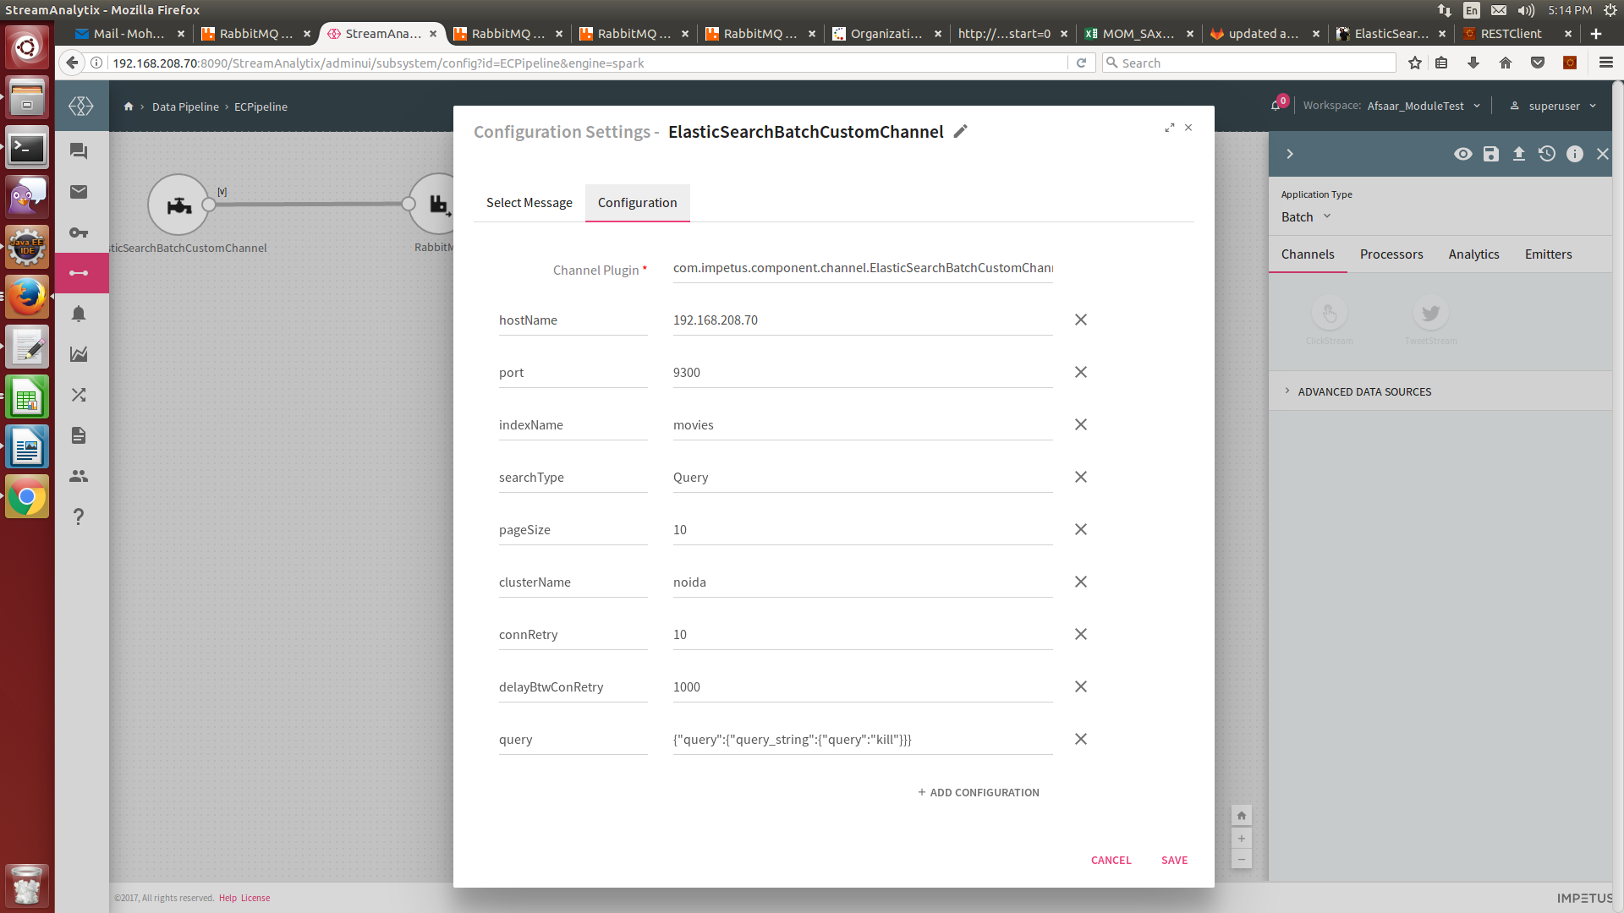When **searchType** is **Query,** custom channel can fetch data on the basis of query and query string.

1. 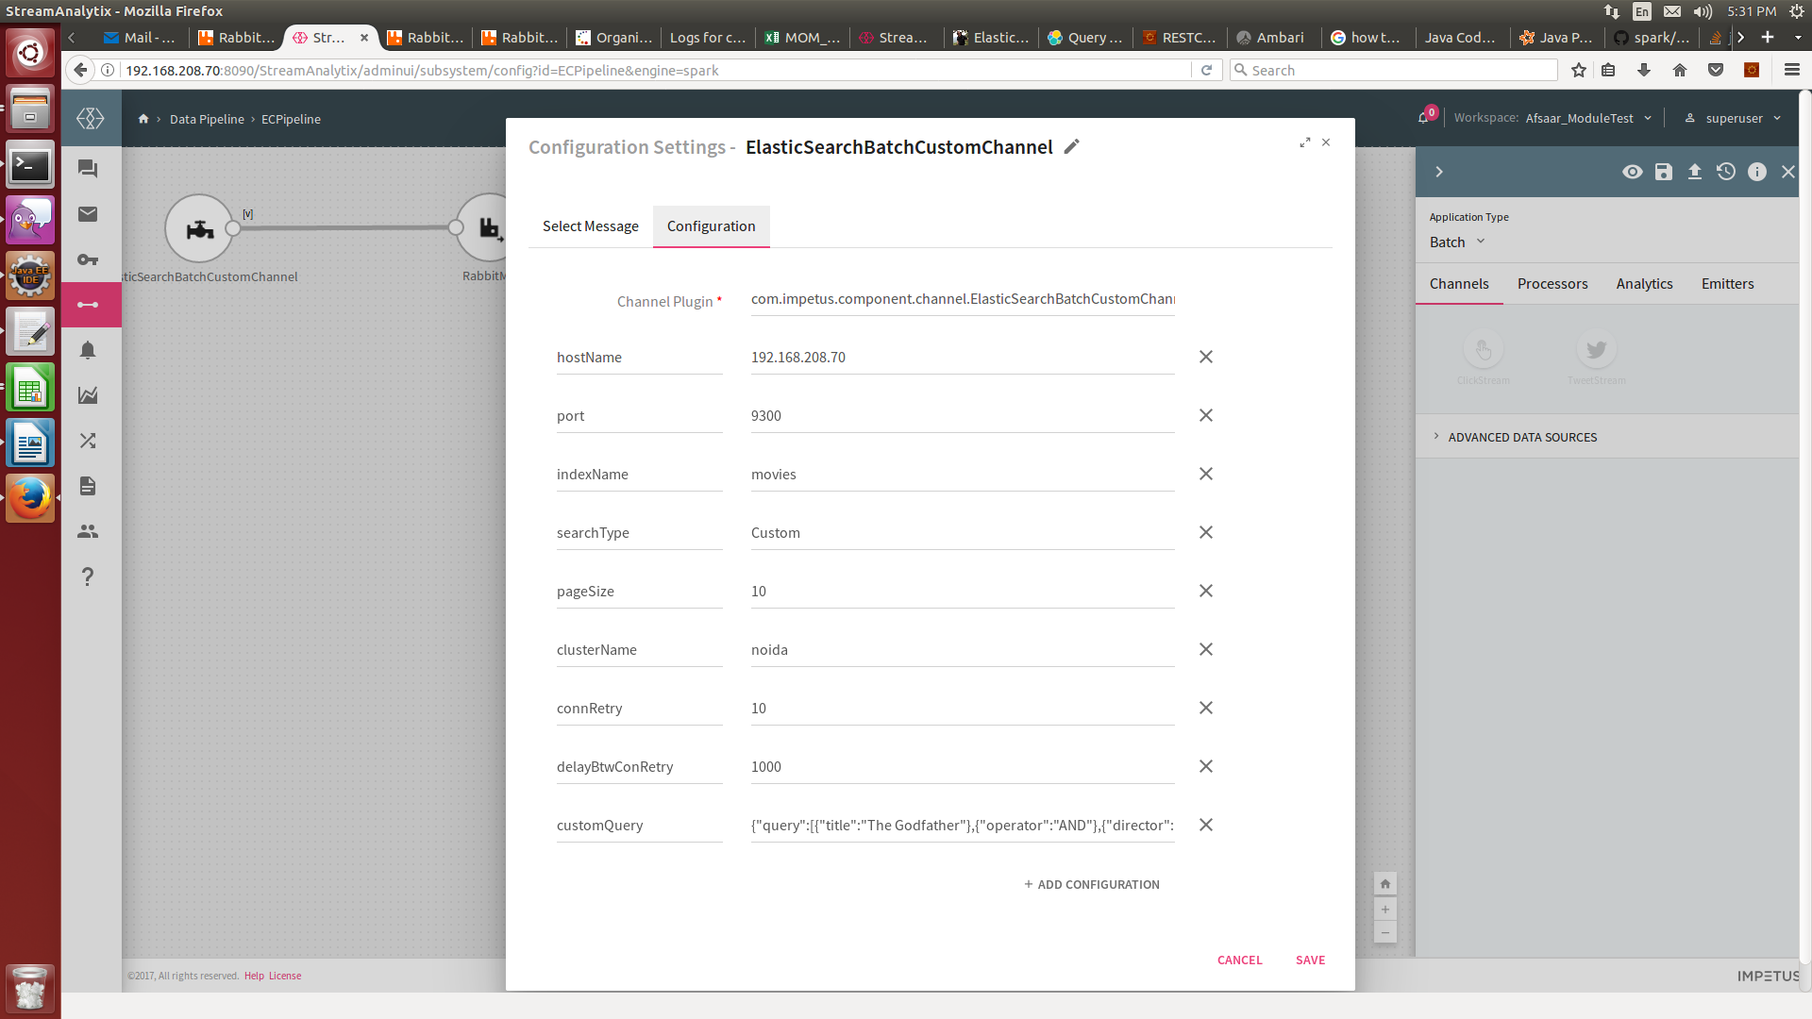when **searchType** is **Custom**, Custom channel can fetch data on the basis of dynamic queries in JSON format.

**Custom Filter parameters:**

|  |  |
| --- | --- |
| **Field** | **Description** |
| **searchType** | Custom |
| **customQuery** | Custom Query can be entered in JSON format  For e.g:  {"query":[{"title":"The Green Mile"},{"operator":"AND"},{"director":"Neeraj Pandey"},{"operator":"OR"},{"year":"1999"}]} |

To give us your feedback on your experience with the application and report bugs or problems, mail us at [support@streamanalytix.com](mailto:support@streamanalytix.com)